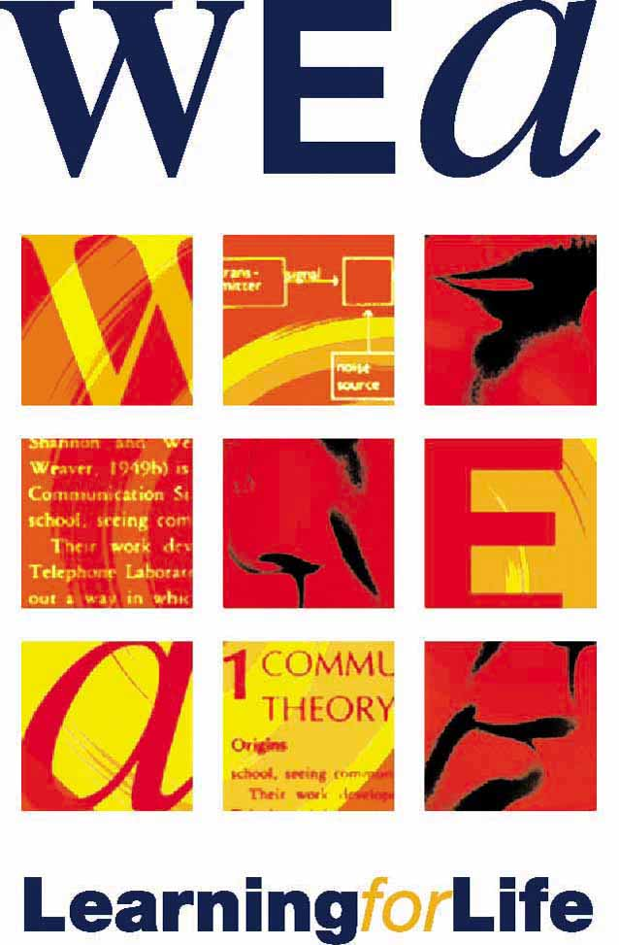


WOMEN and HEALTH
and SAFETY course

This course is for all reps who would like an opportunity to
look at women’s health and safety issues in the workplace

It will run for 3 consecutive Tuesdays;
1st, 8th and 15th November 2011, 9.30a.m - 4.30p.m
at
WEA Trade Union Learning Centre
96 – 100 Clifton Street
London EC2A 4TP
(short walk from Old Street/Moorgate/Liverpool Street/
Shoreditch stations and on lots of bus routes)

To apply please fill in the application form overleaf and return to
Monica Gort, WEA London Region, 96 – 100 Clifton Street, London EC2A 4TP
or mgort@wea.org.uk

For further information please contact Monica on
0207 426 1976 or 07711855887



In partnership with London Hazards Centre www.lhc.org.uk

The course will help you to understand symptoms of ill health caused by work, to identify relevant H&S legislation, policies and other information, and to feel more confident about raising the issues of women’s health and safety in your workplace and union.
--------------------------------------------------
(Please WRITE clearly and keep a copy for your records)

►COURSE TITLE:

►START DATE:

►YOUR FULL NAME:

Home address:

Postcode: Tel:

Email:

Trade Union:

Union branch:

Union posts held:

Previous union course/s:

Name and address of employer:

√ I am a fully paid up member of my union

Signature of applicant: Date:

Signature or stamp of full time union officer/branch secretary

