ED/0015/10
Circular No. NP/073/10

12th April 2011

To: All Branches & Regional Councils, Regional Organisers and Head Office Officers.

Dear Colleague

Young Members’ Education Event – Tolpuddle Martyrs Festival and Rally Conference 2011

In 1834, in a small and remote Dorset village called Tolpuddle a momentous series of events began which are still sited as the birth of what the world knows now as Trade Unions. Six very ordinary agricultural workers met to discuss how they might improve their wages (about 30 pence a week in today’s money) after three wage cuts that had forced their families to near starvation. These first meetings were probably the first ever Trade Union Education meetings as they worked out a plan to improve their lot. The authorities moved quickly against these brave men and as a result they were sentenced to Transportation (to Australia) and would not see home or their families for over three years. Only because of the pressure in the UK of other trade unionists did they eventually return home, also their families had been able to survive their sentence as a result of donations from trade unionists across the country. The principles enacted over this period are the very foundation of Trade Unions today and the RMT Trade Union.

To learn more about these events and enjoy one of the finest Trade Union Festivals anywhere in the world I am inviting any of our RMT Young Members to apply to attend this Festival and Rally.

It is intended to arrange accommodation a close distance away from the village Tolpuddle (to be advised on your acknowledgement letter). You would need to arrive the evening of Friday 15th July. On Saturday the 16th there will be a series of discussions and educational sessions that will set out to explain the events of the early 1830’s in Tolpuddle and what they mean today. On the 17th July the RMT group will all attend the Festival and Rally in Tolpuddle which is a truly fantastic event. The group would depart following the close of the Festival.

If you wish to attend this event please complete the attached application form and return to the RMT Education Officer, Andy Gilchrist, at UNITY HOUSE, 39 CHALTON STREET, LONDON NW1 1JD.

To assist you to attend your Union will reimburse all your reasonable travel costs to and from the event and will cover all your accommodation and entry fees. Also if your employer will not grant you paid release from work to attend this event your Union will reimburse any loss of wages to the agreed maximum level.

I sincerely hope you will wish to attend and I look forward to seeing you there.

Yours sincerely
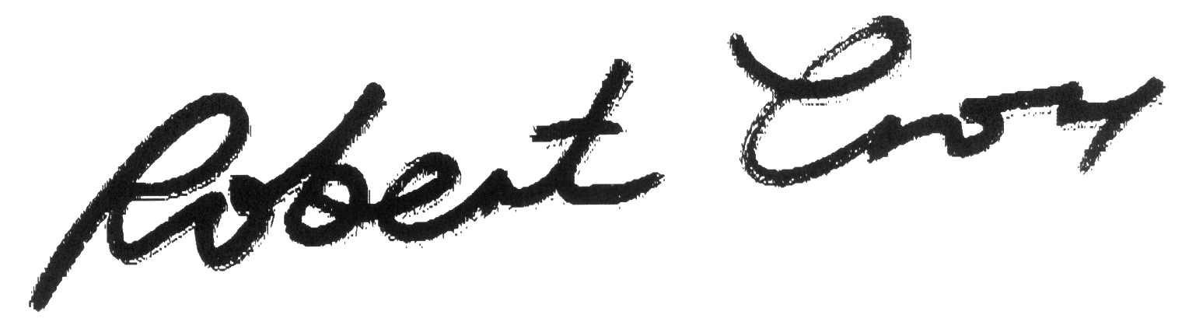
Bob Crow
General Secretary

