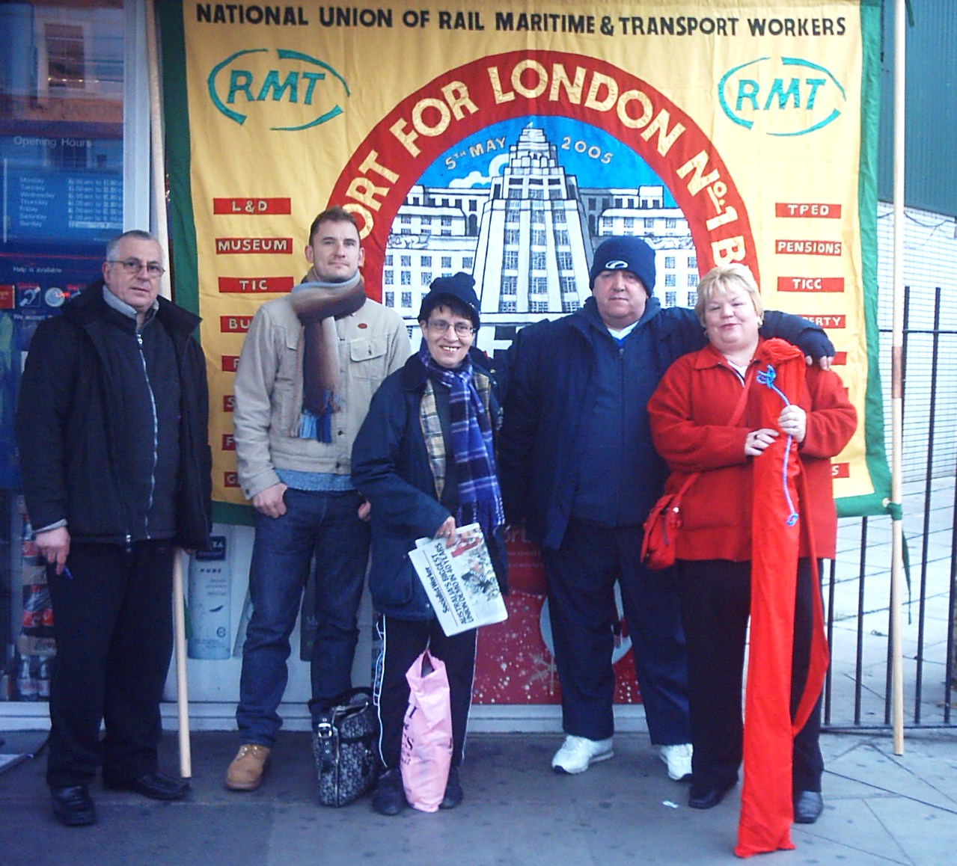
RMT recognised members in TfL vote decisively for strike action

Recognised members in Travel Information Call Centre, Travel Information Centres, all areas of Oyster, Lost Property Office & Customer Services voted 63% in favour of strike action and 77% in favour of action short of the strike. This is a decisive mandate for industrial action and a clear message that TfL RMT members will fight to defend their current terms & conditions and for the fair and decent reward they deserve for the additional Olympic and Paralympic workloads.

Management aren't treating us with the dignity and respect we deserve by trying to break existing agreements and ignore childcare issues by restricting annual leave in July, August & September, and by refusing to offer a decent pay settlement for TfL staff who don't or can't volunteer as Travel Ambassadors. This is why we are dispute.

The other trade unions are in dispute with TfL management but are not doing anything to fight for their members.

Peter Hendy has stated publicly that “every member of our 30,000 staff will play an important role in achieving the significant and unique challenges ahead” yet TfL management ignores the vital role all TfL workers will play in successfully transporting athletes, officials and spectators around London in addition to the commuters, students, residents and tourists who usually use London's transport network.

RMT is available for talks at anytime about the Olympic paydeal and pushed TfL management to go to ACAS on numerous occasions but management refuses to go.

At the branch meeting on 11 June members decided on hold a 24 hour strike and overtime ban for action short of a strike.

Strike action:
Members should not book on for shifts starting between 21:30 Sunday 1st July; returning to work for duties that start after 21:30 on Monday 2nd July 2012.

Strike picket: Monday 2nd July 6.45am outside Victoria Travel Information Centre; 8:30am outside Windsor House.

Action short of strike:
Members should not work any overtime or restday working from 19:00 Sunday 8th July until 19:00 Sunday 15th July. Work your contractual hours and duties only.

- United action will send a strong message to TfL management that they must remove the all restrictions on annual leave and table a decent pay offer that covers all TfL staff for the whole Olympic period.
- Industrial action to protect our existing agreements will show our strength and solidarity in the workplace, essential for when we fight for future paydeals and to protect jobs.
- Join up colleagues, including fixed term & agency staff, before strike action to boost solidarity. Any new members will be legally protected when they take strike action alongside you even if they didn't vote in the strike ballot.
- RMT TfL staff won't be alone in taking strike action, staff at Service Control will be taking strike action on the same day.
- Bus workers in Unite the union took strike action on Friday 22 June in response to the bus operators' refusal to table a decent Olympic paydeal.

Effective strike action can win better pay, terms and conditions; reinforce trade union strength and solidarity in the workplace; and send a clear message to management that RMT members will not be bullied, divided or undermined and will fight for the best possible Olympic pay and annual leave deal.

Come out on strike and support action short of a strike!

If you have any questions contact your reps - Maria Taylor, Karen Fay, Andre Ashman, Steve Poole or text Linda Wiles

Yours In Solidarity,

Linda Wiles
TFL No.1 Branch Secretary Linda.j.wiles@ntlworld.com; 07990894576

