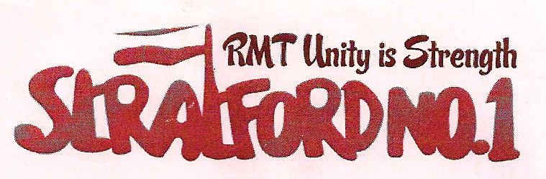

Sacked train operator Tunde Umanah has won his appeal and his job back following a robust campaign of action by the RMT union.
RMT member and activist Tunde, a well-respected and trusted Leytonstone driver was sacked in June at a CDI for his involvement in a PTI incident at Woodford station.
By contrast, the Leytonstone DTSM who set off the incident in the first place was given a 12-month warning, having given inconsistent versions of the incident; altered numerous parts of his story and later ‘surprisingly’ claimed he had been in fear for his life.
Tundes’s actions throughout this unfortunate incident were unintended and the chair of the CDI panel actually commended Tunde on his honesty and integrity throughout the investigation and the CDI.
FURY AT UNSCRUPULOUS MANAGEMENT
Tunde’s sacking prompted fury on the Central Line and his workmates were outraged by the injustice and the unethical behaviour of managers connected with the case. Drivers were particularly angry with the DTSM involved in the incident, who, without scruples of conscience, and in contempt for right and justice, had knowingly set up Tunde.
LEYTONSTONE TOSM CONCEALED MEMOS FROM CDI PANEL
Management’s investigation into the incident was corrupted from the outset and memos relating to the incident were wrongly concealed by a TOSM and withheld from the CDI brief.
RMT FIGHT FOR JUSTICE
Following Tunde’s sacking, a massive campaign for justice was launched by the RMT supported by many other rail unionists on the Central Line.
JUSTICE PREVAILS
With strong representation and support from the RMT, Tunde appealed his unfair sacking, and on 11th August was notified he had won his appeal and his job back.

TUNDE THANKS WORKMATES
Tunde has expressed his thanks for all the support and solidarity shown by the RMT and his depot colleagues on the ground that made management reconsider their unfair actions and reinstate him in his job.

Newsletter August 2011

JOIN

RMT VICTORY: LEYTONSTONE DRIVER

REINSTATED ON APPEAL

FOLLOWING TAINTED INVESTI

LONDON UNDERGROUND BOSSES

LONDON



Britain’s biggest specialist transport union

Don't go it alone...
UNITY IS STRENGTH

Stand beside your workmates and be protected by Britain's fastest growing union

To join call FREE on

0800 376 3706
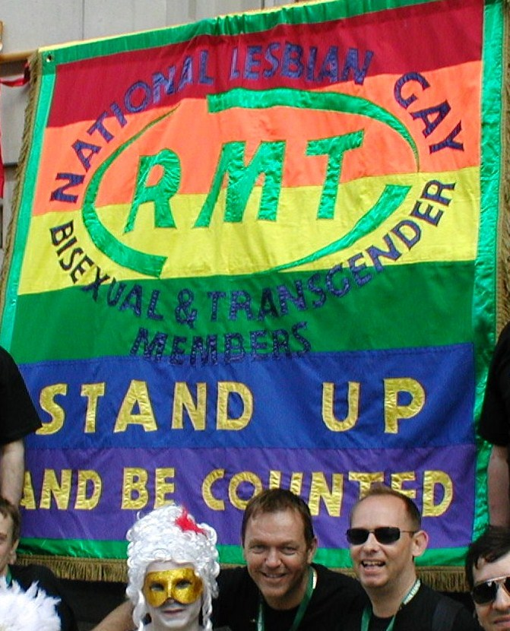
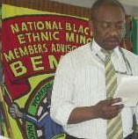


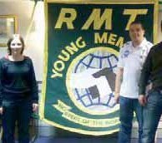

Your local RMT branch meets on the second Thursday of every month 17:00hrs -19:15hrs at the Ex-Services Club, Harvey Road, Leytonstone, E11

Includes London Underground Central Line station staff from Holborn eastwards, drivers at Leytonstone, Hainault and Loughton, service control staff at Stratford Market depot, and bus workers at Leyton

ALL MEMBERS WELCOME

RMT rejects LU’s latest below-inflation pay offer
RMT General Grades Committee decision:

We reject the latest offer from London Underground on the following grounds:
- The revised offer of 5% for this year is still below the February RPI figure of 5.5% and is thus a real-terms pay cut. It is important that pay rises keep pace with, or preferably exceed, price rises, and that the same month's RPI figure is used each year in order to track price rises year-on-year.

- The offer does not include a minimum 'underpin' percentage (eg. 'minimum 3%') for subsequent years. Neither does it include a flat-rate minimum figure for the pay rise for this year or subsequent years, which would benefit lower-paid grades. This is union policy, and we will press this issue in further talks.

- The offer does not seriously address our claims for improved working conditions, such as reduced hours or equal travel facilities.

- At five years, the offer covers too long a period of time. Although LU would like members to believe that this gives them ‘security’, in truth it would tie us to a pay formula regardless of changing economic and political circumstances and would hamper this union’s ability to campaign for improved pay and conditions year-on-year, and we expect that management would use the time to further attack jobs and conditions.

Lesbian, gay, bisexual and transgender workers

Young workers

Disabled workers

Black and ethnic minority workers

Women

