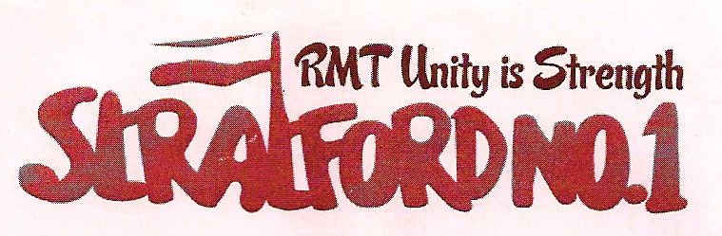

RMT Stratford No. 1
Branch Newsletter

28th January 2012

44 YEARS SERVICE AND
13 WORKING DAYS ‘TIL RETIREMENT -
“HERE’S A 23-WEEK WARNING!”

With 44 years service and only 13 working days until his retirement, Steve Hover, a respected and well-liked Loughton driver, was summoned to attend a Local Disciplinary Interview (LDI) for infringing LUL’s punitive sickness policy, and given a vindictive 23-week warning.
Steve had fallen foul of LUL’s attendance policy, despite conscientiously returning to work the very next day after the single day’s sickness that triggered the disciplinary.
The Train Operations Standards Manager (TOSM) had the option to talk informally with Steve, but chose to ignore Steve’s efforts to minimise his non-attendance.
At the disciplinary, the TOSM stated she had decided to issue a 23-week warning, and contemptuously added that she could have issued a 26-week warning!
The RMT regards this LDI decision as grotesque and unfair, and an immediate appeal has been submitted.
Retirement is generally a happy time, usually marked with celebrations and tokens of the employers’ gratitude. But not so if you work for London Underground!
Sadly, London Underground’s open contempt towards Steve’s 44 years service is depressingly “consistent” with the overbearing style of management at Loughton.
With the Olympics and Queens Diamond Jubilee happening in less than six months, you’d think management would be motivating drivers, rather than adding to the already low moral at Loughton depot.

WE MUST PUT RIGHT THIS INJUSTICE!
PLEASE SUPPORT STEVE HOVER
PLEASE SUPPORT YOUR UNION

RMT BRANCH MEETINGS

COME ALONG

GET INVOLVED

HAVE YOUR SAY

Your local RMT branch meets on the second Thursday of every month 17:00hrs -19:15hrs at the Ex-Services Club, Harvey Road, Leytonstone, E11

Includes London Underground Central Line station staff from Holborn eastwards, drivers at Leytonstone, Hainault and Loughton, service control staff at Stratford Market depot, and bus workers at Leyton.

ALL MEMBERS WELCOME

