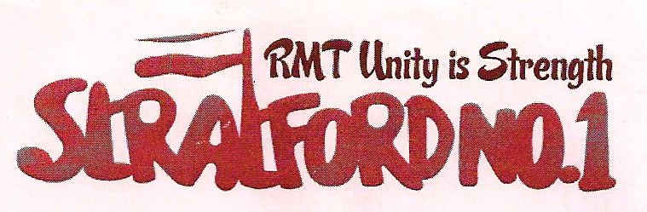

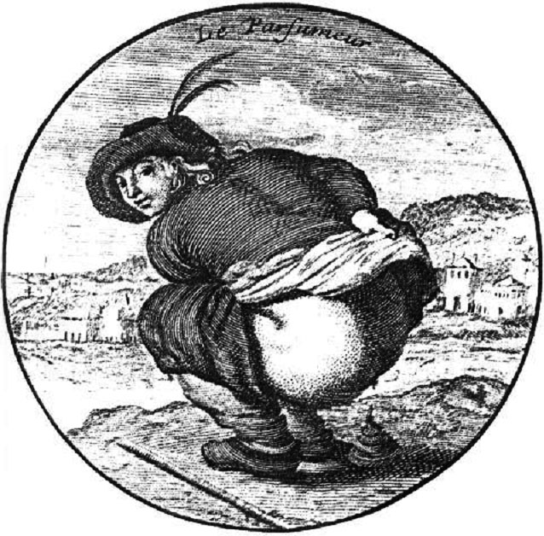
RMT Stratford No. 1
Branch Bulletin
6th September 2011

JOIN
MANAGEMENT TOILET LOGS CAUSE A STINK

DRIVER SH*T LIST
LIST THREAT

RMT DEMAND FOR DIGNITY

Bladder-Cops Target PNRs

take

FOLLOWING TAINTED INVESTI
LONDON UNDERGROUND BOSSES

LONDON

Britain’s biggest specialist transport union
Don't go it alone...
UNITY IS STRENGTH
Stand beside your workmates and be protected by Britain's fastest growing union

To join call FREE on
0800 376 3706
London Underground’s truculent management regime is now threatening train operators with disciplinary action for taking “too many” PNRs.

Local managers across LUL have been instructed to create an EIRF each time a train operator takes a personal needs relief and these are then
recording on personal files. On the H&C line a T/Op has been threatened with disciplinary action.

Management tried this last year and only stopped because the RMT took it to the highest level and made it clear that LUL were breaching their own dignity at work policy.

The RMT will never accept that train operators have to be demeaned in this way unless all managers - from the Chief Operating Officer down - also have to go through the humiliation of requesting to use the toilet and then having it recorded.

Medical evidence shows that health problems, including constipation, abdominal pain, diverticulitis, and hemorrhoids, can result if individuals delay defecation. Holding off peeing can lead to a thickening of the bladder wall and the need to pee even more frequently. It can also result in urinary tract infections and, in rare situations, renal damage.

The RMT is referring this issue (again) to 55 Broadway. In the meantime the advice is:

DON’T ALLOW YOURSELVES TO BE INTIMIDATED.
IF YOU NEED A BREAK, TAKE ONE!

ignoring the urge to empty the bowel can lead to constipation. Over time, repeatedly ignoring signals that the bowel is full can lead to bowel distension, a reduction in muscle tone and even to accidents of the bowel."
Holding off peeing can also lead to a thickening of the bladder wall and the need to pee even more frequently.
Waiting to go go
Not getting to go when you need to can cause health effects including:

• urinary tract infections (UTIs)
• renal damage
• constipation
• abdominal pain
• diverticuli
• haemorrhoids
• bowel distension
• incontinenceignoring the urge to empty the bowel can lead to constipation. Over time, repeatedly ignoring signals that the bowel is full can lead to bowel distension, a reduction in muscle tone and even to accidents of the bowel."
Holding off peeing can also lead to a thickening of the bladder wall and the need to pee even more frequently.
Waiting to go go
Not getting to go when you need to can cause health effects including:

• urinary tract infections (UTIs)
• renal damage
• constipation
• abdominal pain
• diverticuli
• haemorrhoids
• bowel distension
• incontinenceignoring the urge to empty the bowel can lead to constipation. Over time, repeatedly ignoring signals that the bowel is full can lead to bowel distension, a reduction in muscle tone and even to accidents of the bowel."
Holding off peeing can also lead to a thickening of the bladder wall and the need to pee even more frequently.
Waiting to go go
Not getting to go when you need to can cause health effects including:

• urinary tract infections (UTIs)
• renal damage
• constipation
• abdominal pain
• diverticuli
• haemorrhoids
• bowel distension
• incontinence

Your local RMT branch meets on the second Thursday of every month 17:00hrs -19:15hrs at the Ex-Services Club,
Harvey Road, Leytonstone, E11

Includes London Underground Central Line station staff from Holborn eastwards, drivers at Leytonstone, Hainault and Loughton, service control staff at Stratford Market depot, and bus workers at Leyton

ALL MEMBERS WELCOME

