RMT LONDON TRANSPORT REGION
STATION AND REVENUE GRADES COMMITTEE
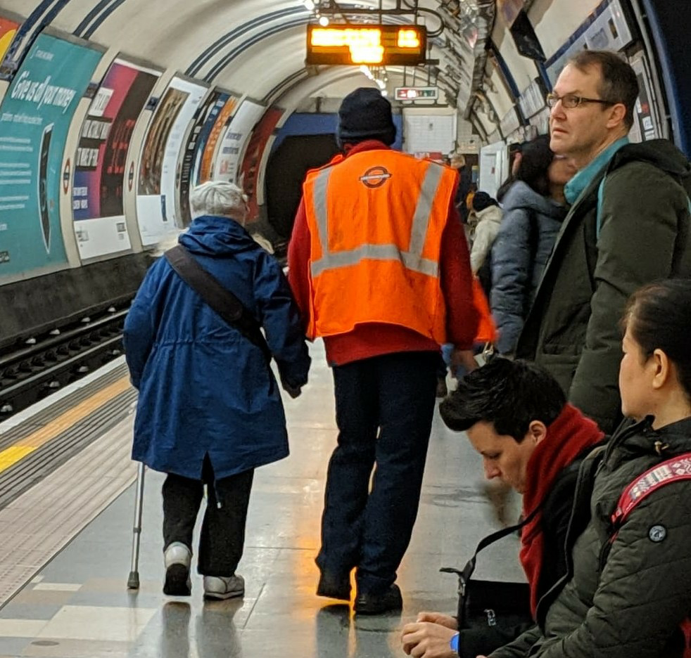
All stations and revenue members welcome
Meet 1400
Thursday 20th June
Bread and Roses at The Chapel 308-312 Grays Inn Road Kings Cross London WC1X 8DP
- Meet reps across the network
- Discuss issues from your workplace
- Pay claim, Transformation, pom room sackings

- Find out what's going on across the region
- See overleaf for more details or text/Whatsapp Marie Harrington (Chair) on 07814740308
What is the station and revenue grades committee?
These are monthly meetings that bring together rank and file members, reps and activists. They offer a chance to have more in depth discussions about matters that affect our grades than may be possible at your branch meeting. All stations and revenue staff are welcome to raise issues and plan how we are going to fight for a better deal across the network.

Is it just a talking shop?
No. We report to the London Transport Regional Council to make sure that our concerns are addressed by the region as a whole. We can also coordinate action and identify local issues that other areas may not yet be aware of. This lets us respond swiftly and appropriately to attacks on our grade.

This month
Red Tabards
Staffing disputes
POM room issues
Victimised members
Local reports

Please make every effort to attend, your contribution is important!

