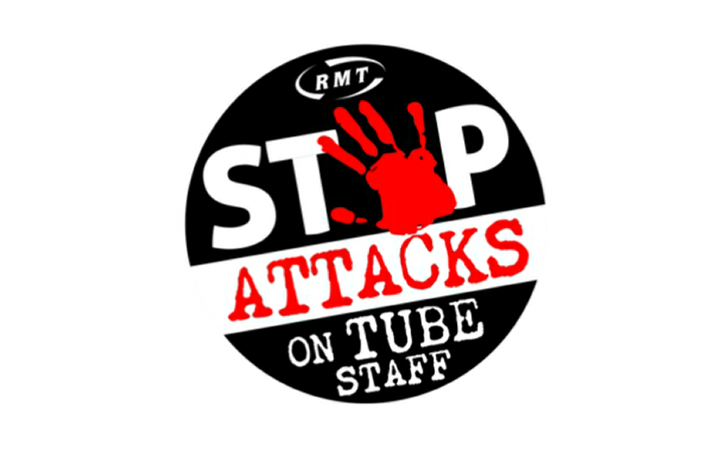
RMT LONDON TRANSPORT REGION
STATION AND REVENUE GRADES COMMITTEE
Annual General Meeting
All stations and revenue members welcome
Meet 1400
Thursday 20th February
The Lucas Arms, 245A Grays Inn Rd, London WC1X 8QY
As this is our AGM, we will be electing officers and making a plan for the year, please try to attend if you can
- Meet reps from across the network
- Discuss issues from your workplace
- Find out what's going on across the region
- See overleaf for more details or text/Whatsapp Marie Harrington (Chair) on 07814740308
What is the station and revenue grades committee?
These are monthly meetings that bring together rank and file members, reps and activists. They offer a chance to have more in depth discussions about matters that affect our grades than may be possible at your branch meeting. All stations and revenue staff are welcome to raise issues and plan how we are going to fight for a better deal across the network.
Is it just a talking shop?
No. We report to the London Transport Regional Council to make sure that our concerns are addressed by the region as a whole. We can also coordinate action and identify local issues that other areas may not yet be aware of. This lets us respond swiftly and appropriately to attacks on our grade.
What happens at the annual general meeting?
We will identify what our priorities are for the coming year and plan our activities. We will also elect officers
Which officer positions will be available?
We have a chair to ensure that the meetings allow everyone a voice and run to time. A vice chair to run the meetings when the chair is not available.
We also elect a secretary to make sure meetings are recorded correctly and agreed actions are followed up. An assistant secretary is elected for when the secretary can't attend. All the above positions are open to election at the AGM
Who can stand?
You can! Any RMT stations or revenue member can stand for these positions.
Please make every effort to attend, your contribution is important!

