|  |
| --- |
| index 1  ***No more public money for Racism, Sexism and Union Busting!*** |
| *Reinstate Petrit mm.jpgihaj* |

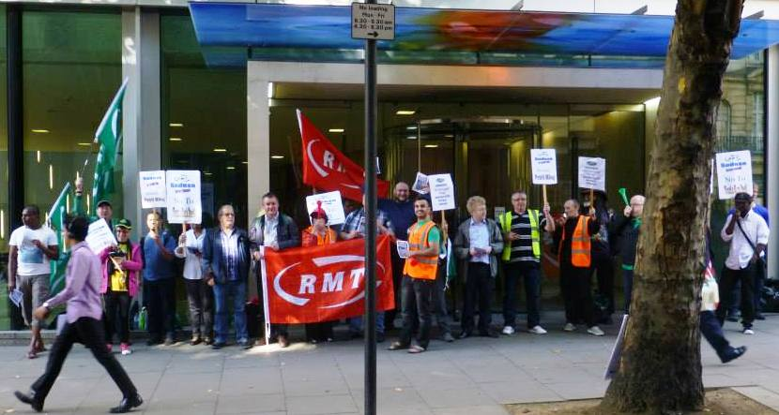

**We are campaigning against victimisation, discrimination, union busting and dismissal of our colleague and union representative Petrit Mihaj.**

**It’s been over a year since our rep Petrit Mihaj was victimised for his Trade Union (TU) activities and unfairly dismissed as proven in court. (Ref: P Mihaj v Sodexo Ltd)**

**Our campaign continues into its second year. After many successful demonstrations in 2014 and 2015, The RMT is stepping up this campaign by asking MP’s and candidates in the General Election campaign to stop funding racist and union busting employers.**

***You can help by calling for Petrit’s reinstatement***

**Boycott Sodexo and join our campaign for justice by emailing**

* **Sodexo Chief Executive Debbie White:** [**debbie.white@sodexo.com**](mailto:debbie.white@sodexo.com)
* **TfL Catering Director Nigel Hall:** [**nigel.hall3@tube.tfl.gov.uk**](mailto:nigel.hall3@tube.tfl.gov.uk)
* **Follow the link below, Write to your MP, Mayor of London and GLA Members:** [**http://www.rmt.org.uk/campaigns/underground/petrit-mihaj-v-sodexo/**](http://www.rmt.org.uk/campaigns/underground/petrit-mihaj-v-sodexo/)
* **For further information or getting involve in this campaign contact Petrit Mihaj on 07877547727 or email** [**petrit-mihaj@hotmail.co.uk**](mailto:petrit-mihaj@hotmail.co.uk) **or visit the** [**www.rmtlomdoncalling.org.uk**](http://www.rmtlomdoncalling.org.uk)

***Bullying, Racism, Discrimination and Union Bashing***

* **Out of five RMT Reps, three have been sacked and two have faced disciplinary actions.**
* **10% of RMT members have brought claims against Sodexo to Employment Tribunals. 20% have unresolved grievances**

***SODEXO ON THE NEWS...***

Sodexo is a multinational corporation raking in billions but paying workers below the living wage. It once had a handbook for managers on how to fight unions in the workplace. It also made an appearance in the well-known documentary Super Size Me for its unhealthy food options in school, hospitals, care homes, prisons and other parts of the public sector.

Sodexo may be one of the Government’s major private contractors but it has a long history of both union-bashing and treating its workforce like dirt.

* ***“Punch a black week”***

Sodexo’s Claims about racism in its defence division – sparked after an employee was hit by her director who said it was "***punch a black week***" Sodexo accepted the events took place, the black female manager left the company with a six-figure payout.

Sodexo’s self-satisfaction is misleading and the culture of bullying and racism isn’t restricted to Sodexo’s UK operations. Few years back the company was forced to pay £47.2 million to settle a lawsuit brought against Sodexo. After all, there have been several charges made against Sodexo for discrimination, including one filed by thousands of black employees who claimed they were segregated within the company—Sodexo paid millions to settle the suit.

[**http://www.theguardian.com/uk-news/2014/jun/18/sodexo-military-contract-racism-allegations**](http://www.theguardian.com/uk-news/2014/jun/18/sodexo-military-contract-racism-allegations)

* ***Hospital trust ends £15m contact with private firm Sodexo***

Private firm Sodexo was awarded a £15 million a year contract to provide the services in December 2012. However it has been beset with problems from the start, including not giving staff their proper wages for four weeks over Christmas and the threat of industrial action the company’s failure to pay the living wage.

[**http://m.theargus.co.uk/news/11877982.Hospital_trust_ends___15m_contract_for_cleaning__catering_and_portering_from_private_firm_Sodexo/**](http://m.theargus.co.uk/news/11877982.Hospital_trust_ends___15m_contract_for_cleaning__catering_and_portering_from_private_firm_Sodexo/)

* ***Hospital’s ‘fast food’ is unhealthy, protest Whittington staff.***

ARTERY-clogging fried chicken on sale in the Whittington Hospital restaurant does not set a good example of healthy living, union chiefs have warned.

Trade union Unison’s Whittington rep said: “They serve the unhealthiest food you can ever have. It is fast-food type, fried chicken and chips, and they think that is suitable for health workers. “Nurses in the diabetes clinic have complained about the food. And the prices have also nearly doubled on basic items.

Sodexo, which runs the patient meals service and on-site restaurant at University College Hospital, in Euston, provides a similar service to many other London hospitals, including Barking, Havering and Redbridge University Hospitals NHS Trust and Queen Mary’s Hospital, in Roehampton.

[**http://www.islingtontribune.com/news/2014/dec/hospital%E2%80%99s-%E2%80%98fast-food%E2%80%99-unhealthy-protest-whittington-staff**](http://www.islingtontribune.com/news/2014/dec/hospital%E2%80%99s-%E2%80%98fast-food%E2%80%99-unhealthy-protest-whittington-staff)

* ***“They say Sodexo – we say: Oh no” Sodexo hits probation services with massive redundancies***

We have also been told officially that Sodexo do not intend to honour the Enhanced Voluntary Redundancy (EVR) Scheme. This forms part of the agreed National Framework signed by the Ministry of Justice and the Trade Unions. The Secretary of State Chris Grayling gave all CRC’s a lump sum of money that was underwritten by him so that they could pay staff EVR if they needed to reduce the workforce. Sodexo have said that they think this is too expensive and will not be honouring this agreement.

The posts at risk cover all grades of staff from admin, PSO’s, PO’s, middle managers and corporate services. Ian Lawrence, Napo General Secretary said “we are angry and disappointed about this news. Probation staff have been through hell over the last 18 months dealing with Grayling’s so called reforms and now many of them are facing redundancy and job insecurity. When we met with Sodexo earlier this year they told us there would be no reductions in workforce. The use of call centres and machines instead of highly skilled staff is downright dangerous and will put the public at risk.”

[**https://www.napo.org.uk/news/sodexo-hits-probation-services-massive-redundancies-press-release**](https://www.napo.org.uk/news/sodexo-hits-probation-services-massive-redundancies-press-release)

***No more public money for Sodexo!***

***Join us on May-Day demonstration for workers’ rights outside Sodexo’s Head Office***

***From 1030hrs at One Southampton Row, Holborn, London. WC1B-5HA***

 **www.rmt.org.uk**