RMT LONDON REGION
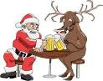 CHRISTMAS SOCIAL
Friday 12th December, 6pm-late
The 12 pins pub, Finsbury Park
Food, Bar and Disco
ALL WELCOLME
Info-Ross Marshall 07914 002 851

