Discipline and Pressure to Return to Work
RMT London Transport Regional Council Disabled Members Covid-19 Bulletin no.4 – 19 May 2020

The Advisory, Conciliatory and Arbitration Service (ACAS) makes clear that the law requires your employer not to discriminate against disabled workers by trying to unreasonably pressure you to return to work, or by unreasonably disciplining you for not going to work. (See picture.)
The law defines you as disabled if you have a physical or mental impairment that has a
long-term (at least a year), substantial, adverse effect on your ability to carry out normal day-to-day activities. Usually, this is judged on a case-by-case basis, but if you have cancer, multiple sclerosis or HIV, then you are automatically deemed to be disabled from when you are diagnosed.
So, if you think you meet this definition, and are off sick, or health advice is that you self-isolate or shield, and your employer is:
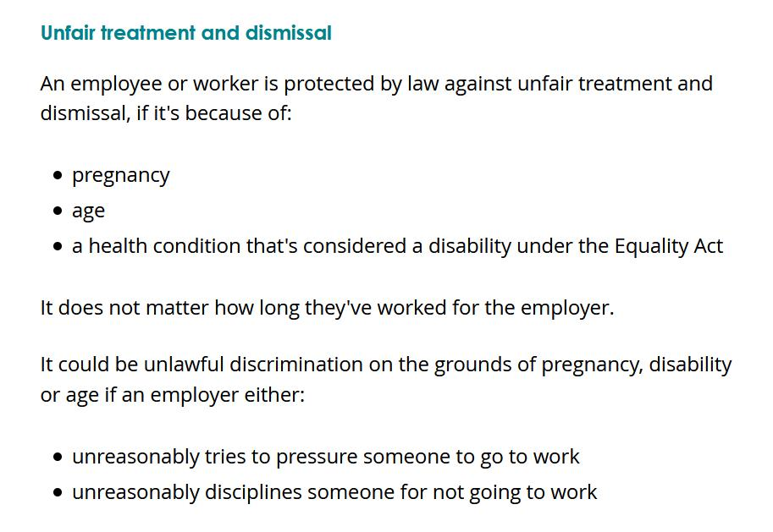
n pressuring you to come back to work – perhaps by repeatedly contacting you, or threatening to stop your pay; or
n starting disciplinary action against you for absence from work
then contact your RMT rep, branch or helpline immediately.

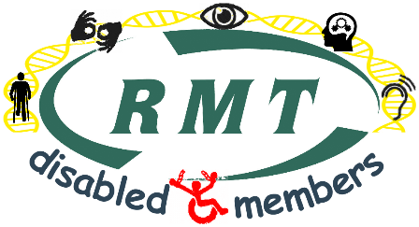
Janine Booth
Disability Officer
RMT London Transport Region
www.rmtlondoncalling.org.uk/disability

