My ref: EO/16
13th June 2012
Circular No. NP/138/12

TO: THE SECRETARY
ALL BRANCHES & REGIONAL COUNCILS

Dear Colleague,

LGBT WORLD PRIDE 2012 – LONDON 7 JULY

On 7 July 2012 visitors from around the world will join one million people on the streets of central London to celebrate World Pride 2012 – the largest ever LGBT Pride festival in the UK. RMT will be supporting the TUC’s section of this festival in promoting trade unions to the LGBT community and the wider world as champions of LGBT equality.

To make the most of this opportunity to boost profile and membership, our LGBT Advisory Committee invites all members to join them and take part in what will be a truly memorable and enjoyable day. Everyone one is welcome to join in the RMT section of the walking parade – and I will be there too. Volunteers are also needed to staff the stall which is most likely to be on Trafalgar Square.

Please do use the attached poster to advertise the event. For any queries or to say you wish to take part, contact our Equal Opportunities Officer (j.webb@rmt.org.uk).

Yours sincerely,

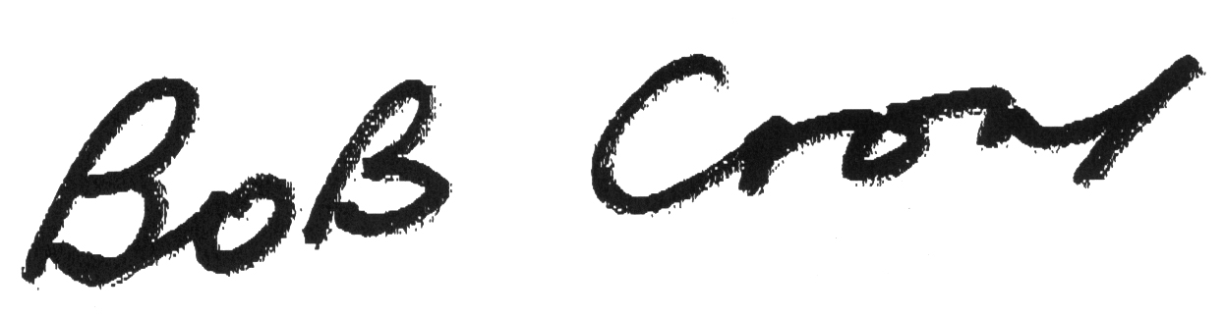

General Secretary

Enc.

Direct Line: 020-7529 8821
E-mail: j.webb@rmt.org.uk

VOLUNTEERS NEEDED


The National LGBT Advisory Committee is participating in World Pride on 7th July 2012 in London.

There will be a stall and a walking group behind the RMT LGBT banner.

To make this a success, volunteers are needed to staff the stall and join the walking group.

Whether you are gay, straight, bi-sexual or transsexual,
come along and have a great family fun day out for everyone.

To volunteer or for more information please contact:
Jessica Webb, Equal Opportunities Officer
j.webb@rmt.org.uk

