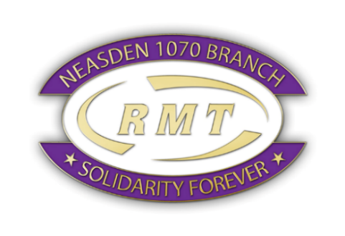
RMT Women Conference, Newcastle, 3-4 March 2023
Hello there!
I’ve just come back from the Women Conference in Newcastle and would like to report back in the hope that more of you will become interested to get involved and participate in building a strong RMT movement of militant working-class women (like Laura Pidcock – former MP in Jeremy Corbyn, said). The conference gathered 60 women from all over the country working for different railway companies - busses too! who shared experiences and solutions to problems women face in the workplace. We all have challenges and we all have solutions to the challenges. Someone else is always going through the same thing and they can share solutions or ideas to deal with them. One way to make things better is to submit resolutions so, on behalf on Neasden Branch, I had the privilege to present “Make flexible working the default” which was voted unanimously to be passed to the Annual General Meeting in June.

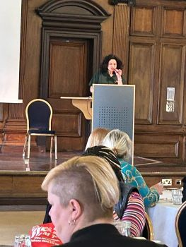

Amongst the speakers was John Leach, the assistant general secretary who recognised RMT needs to do more to involve women in all ranks of the union including lead officers and NEC and who encouraged us to continue fighting to keep our pension, terms and conditions and jobs. All we are asking the government is to leave our hard-earned agreements alone so we have some stability and scrap the laws which permitted P&O to sack 800 people by email.
One task on the agenda was to improve the charter for women which is in the process of being updated so I would like you to share your views and your ideas on what RMT can do to make work-life better.
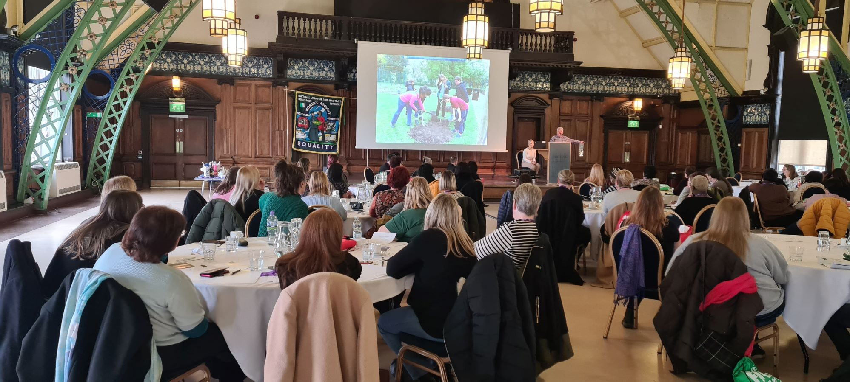

It was not all about work but fun as well and we had dinner, drinks, and dance at the Revolucion de Cuba for a Cuban night.

RMT holds Women Conference every year and I hope to see many of you in 2024 in Bournemouth where I’ll have the honour to be the conference secretary.

I’m sure I’ve captured your interest so why don’t you start attending your branch meetings, get to know the other activists, make your voice heard?

Lumie,
Women Officer
Neasden Branch
6th March 2023

