
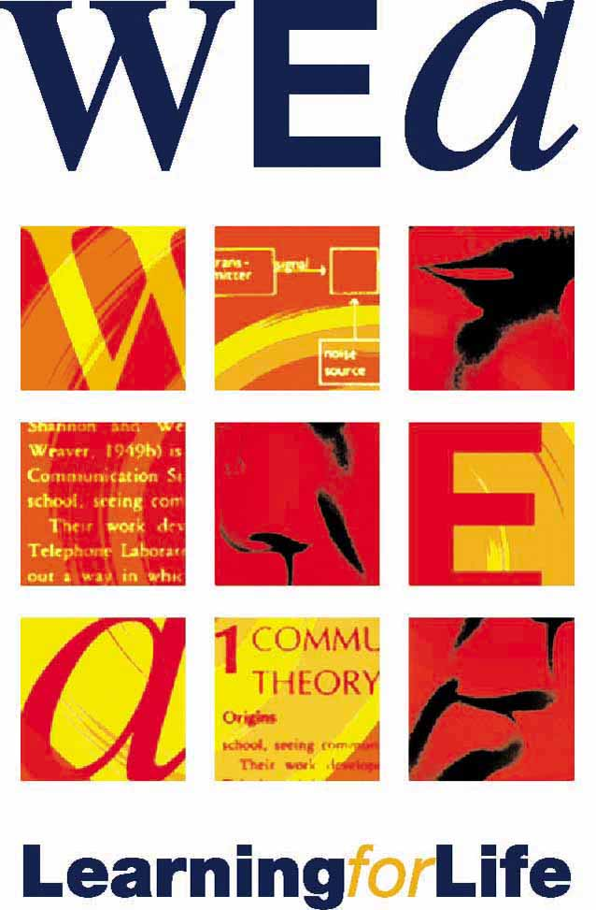

FREE FILM SHOWING!!
Made in Dagenham
Come and join us at the WEA for a drink and a showing
of the film about the struggle for equal pay at Fords.

Find out what courses we are running at the WEA!

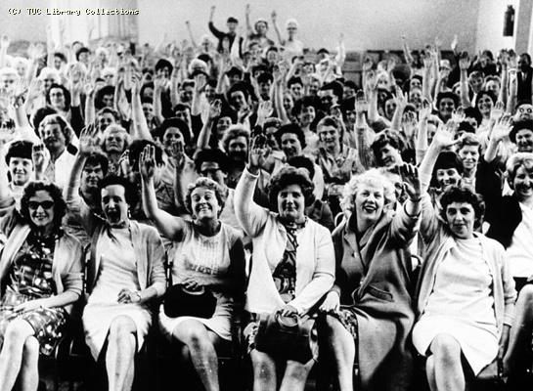

SPEAKERS - Theresa Daly, TUC S&E Regional Education Officer
- Sarah Boston, documentary film maker and author, who interviewed
the Ford Dagenham Sewing machinists for a TUC oral history project

DATE - Thursday 21st July 2011

TIME - 6pm for 6.30pm start - 9pm

VENUE - WEA London Region Learning Centre, 96 – 100 Clifton Street, London EC2A 4TP

Please let Monica know if you will be attending on mgort@wea.org.uk or 0207 426 1976
ALL WELCOME !!
Supported by; RMT London Transport, Hackney UNISON, Hackney Trades Council, PCS London Courts branch, UNITE Clerkenwell and St Pancras branch, Latin American Workers Association
