EVERY JOB MATTERS
Unity Is Strength
EJM Action committee meeting
Tuesday Dec 10 @ 1600 Unity House
What the cuts mean to you
- Every ticket office closed
- 953 job losses
- No night turn supervision
- Station staff to reapply for their jobs
- Cuts in train & track maintenance
- Driverless trains
- Cuts in service control
What can you do?
- Come to the action committee meeting on 10th December @1600 at Unity House, Chalton St London NW1- Euston/Euston Sq stns
- Return your ballot paper- VOTE YES for action
Keep up to date with campaign at:
www.rmtlondoncalling.org.uk

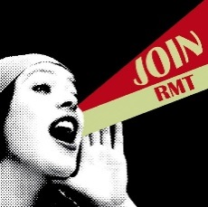 |  | 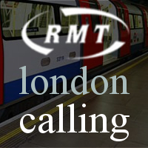

rmtlondoncalling.org.uk facebook.com/everyjobmatters @LULnojobcuts

