ED/0016/11
Circular No. NP/074/11

12th April 2011

To: All Branches & Regional Councils, Regional Organisers and Head Office Officers.

Dear Colleague

Young Members’ Education Event –Durham Miners Gala 2011

The Durham Miners Gala is known historically as ‘The Big Meeting’ as it attracts literally thousands of trade unionist from all over the UK and overseas to celebrate the role that the Miners played throughout the history of the working class and the struggle to improve working conditions for all workers generally. The Gala is centred on a procession of National Union of Mineworkers Colliery bands that make their way through the centre of Durham and arrive at a rally and festival in the heart of Durham.

I am inviting any RMT Young Members to apply to attend this great Trade Union event and to take part firstly in some discussion and education sessions that look at the history and contribution of the miners to our movement as well as looking at the landmark 1984/85 national miners’ strike.

It is intended to arrange accommodation in central Durham (to be advised on your acknowledgement letter). You would need to arrive the evening of Thursday 7th July. On Friday the 10th there will be a series of discussions and educational sessions that will cover the issues involved and the background to the Gala. On the Saturday 11th July the RMT group will be able to witness the procession of colliery bands and then attend the Rally, following the Rally the group will travel home.

If you wish to attend this event please complete the attached application form and return to the RMT Education Officer, Andy Gilchrist, at UNITY HOUSE, 39 CHALTON STREET, LONDON NW1 1JD.

To assist you to attend your Union will reimburse all your reasonable travel costs to and from the event and will cover all your accommodation and entry fees. Also if your employer will not grant you paid release from work to attend this event your Union will reimburse any loss of wages to the agreed maximum level.

I sincerely hope you will wish to attend and I look forward to seeing you there.

Yours sincerely
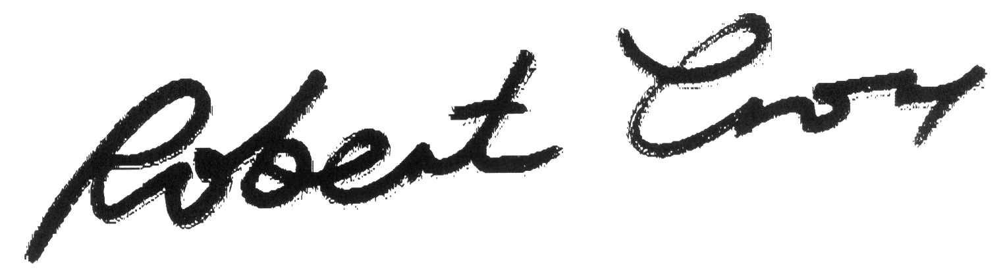
Bob Crow
General Secretary

