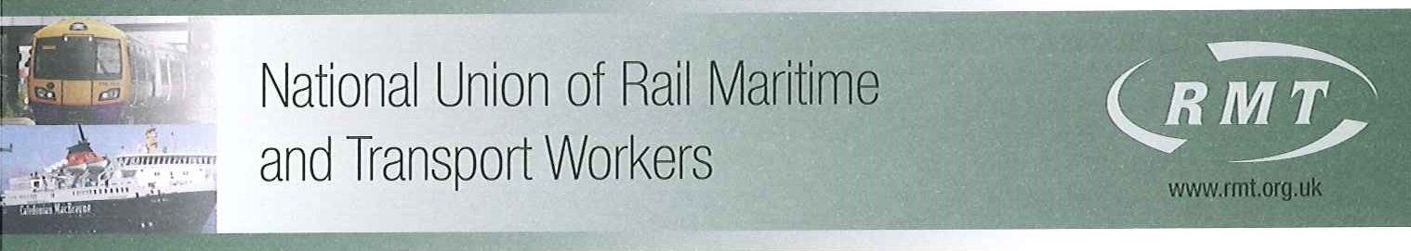

Jean Cockerill
HR Director London Underground Ltd
Palestra
11th Floor
197 Blackfriars Road
London
SE1 8NJ

By Post & E-Mail: jeancockerill@tfl.gov.uk;

Our Ref: TFL/15/4

15th April 2019

Dear Jean,

TFL/LUL TRANSFORMATION

Following the recent exchange of correspondence between you and John Leach regarding the above, I note that the company has failed to follow the correct procedures and adhere to our agreements in respect of the above and is pushing ahead with job losses affecting my members in Track Access Control, Power Control, Service Control, LUCC, Skills Development, Waste, Pumps, Stations Buildings & Civils and Signals Incidents.

As a result of the above, a dispute situation now exists between us over this issue and I will be balloting my members for industrial action. I will provide the appropriate notice in accordance with the legislation in due course and in the meantime, RMT will withdraw from the severely flawed ‘negotiation/consultation process’ with immediate effect. My Reps have been advised not to attend or take part in any briefings or discussions regarding this matter until further notice.

Yours sincerely

Mick Cash
General Secretary

