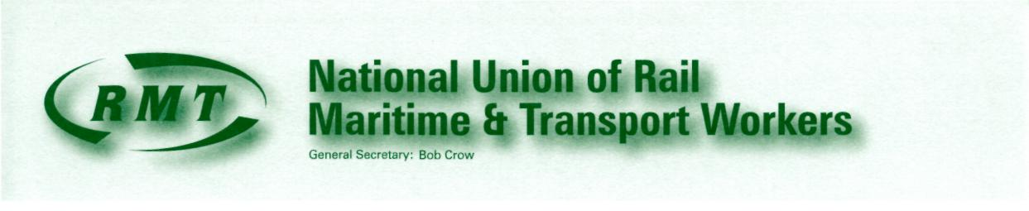
Our Ref: HSS 2/6
Head Office Circular: NP 11/048
10th March 2011

The Secretary
ALL BRANCHES
ALL REGIONAL COUNCILS
REGIONAL OFFICES

Dear Colleague

D.I.S.I - DEFECTIVE IN SERVICE INSTRUCTIONS

I have received a report from the Lead Officer for London Underground regarding the instructions issued by London Underground for the assessment of trains that become defective in service. Your General Grades Committee has made the following decision with regards to the report:

“RMT is completely opposed to section 2.2 of version 3 of the D.I.S.I. that states ‘Generally, the train operator will be the most appropriate person to assess the defect. However, in some cases the controller may decide to arrange for somebody else to attend the train and carry out the assessment’.

RMT maintains that a train operator should have the ultimate responsibility when assessing defects on his/her train and that ‘a train operator will not be expected to compromise safety or to be caused severe discomfort to drive a train to a maintenance depot.’

The RMT will support any train operator member who makes a decision as to whether to withdraw a train from service or not”

Please ensure that the contents of this circular are made available to all interested members.

Yours sincerely

General Secretary

