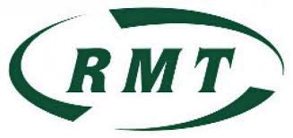

- COME ALONG TO YOUR LOCAL RMT UNION BRANCH MEETING
- HAVE YOUR SAY AT RMT BRANCH MEETING
- GET TO KNOW OTHER CLEANERS

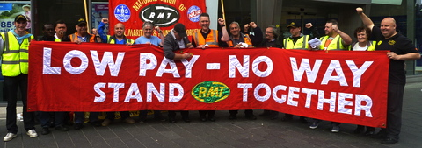

WHEN? THURSDAY 10th JANUARY 2013

TIME? Meet-up from 4:30pm - BRANCH MEETING STARTS 5PM

WHERE? Leytonstone & District Ex-Servicemens Club , 2 Harvey Road,
LEYTONSTONE, London, E11 3DB (3 minutes walk from Leytonstone
Underground Station)

RMT STRATFORD NO. 1 BRANCH MEETS SECOND THURSDAY OF EACH MONTH 5PM
JOIN RMT : CALL FREE 0800 376 3706

