My Ref: MRP 2/1 20th April 2016

Circular Num: NP/123/16
To: The Secretary All Branches, Regional Councils
All Underground and Former LT Employers

Dear Colleagues,

TFL PENSION FUND – CONTRACTING-OUT PROPOSALS

As a result of Government legislation Defined Benefit (Final Salary) pension schemes, such as the TfL Pension Fund, are no longer able to contract-out of the State Second Pension. As from 6th April 2016 both members and employers will see their National Insurance Contributions (NIC) increase by 1.4% and 3.4% respectively as the rebate associated to contracting-out is abolished.

While members will have no choice but to accept the increase in NICs, the Government has put in place legislation which will allow employers to recoup their additional payroll cost by either changing future service benefits or/and increasing contributions without the need of trustee consent. However, employers will have to consult with members and their representatives.
TfL have stated that they do not intend to recoup their contracting-out National Insurance Contribution rebate, estimated to be £25 million per annum. This means the employers additional payroll cost will not be passed on to members of the TfL Pension Fund. However, management has indicated that this may be reviewed in the future.
Government legislation allows employers a five year window between 2016 and 2021 to recoup the rebate.
The National Executive Committee in consideration noted and adopted the following report on 19th April 2016:
“We note that the employer has informed the TfL Pension Fund Trustee Board that they do not intend to recoup their additional payroll costs associated to the ending of contracting-out.

However, while this is good news for members of the fund it is noted that management have indicated that they may revisit their decision. Therefore, any future developments should be reported back to the National Executive Committee.”

I will keep you informed of any developments.

Yours sincerely,

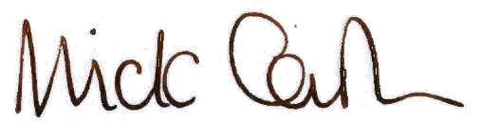

Mick Cash
General Secretary

