Ed/089/12
12th July 2012
Circular No. NP/163/12

To: All Branches, Regional Councils & Council of Executives

Dear Colleagues.
Educational Seminar for RMT Young Members – Burston School Strike Rally 31st August, 1st September & 2nd September 2012 in Norwich & Burston.
In the village of Burston in the early part of the last century a Strike at a local village school ensured its place in history by becoming to this day the longest strike in the UK’s history. Of course the story has so much else to tell us today and it is with this in mind that the Union is organising an Educational Seminar for the weekend of the now annual Burston School Strike Rally held in the village of Burston. RMT Young Members are invited to apply to attend this event in the RMT calendar. The outline of the event is arrival on Friday 31st August Holiday Inn, Carrow Road, Norwich. During Saturday (1st Sept) a full day of educational sessions and activities will enable those attending to understand the background and relevance of the Strike and how it helps us understand many of the issues we face today. Finally on the Sunday (2nd Sept) the course participants will be taken to the village of Burston to enjoy the rally.

If you are interested in attending please fill out the attached application form and return it to the Education Officer. You need to be aged less than 30 years on the 1st September. The Union will meet your accommodation costs for the weekend and your reasonable travel expenses.

I hope you will look to attend this event, and look forward to seeing you there.

Yours Sincerely
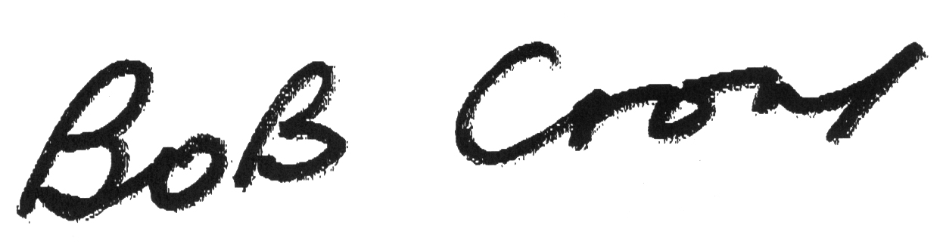
GENERAL SECRETARY

