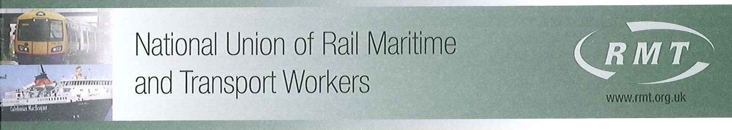

Jean Cockerill
HR Director London Underground Ltd
Palestra
11th Floor
197 Blackfriars Road
London
SE1 8NJ

By Post & E-Mail: jeancockerill@tfl.gov.uk;

Our Ref: LUL/0001

4th April 2016

Dear Jean,

RATES OF PAY & CONDITIONS OF SERVICE 2015 – LONDON UNDERGROUND

Following this Union’s official acceptance on 1st March of the 4-year pay offer for our LUL members, I would be grateful if you could advise me when the applicable increase and backdated monies will be paid to my members?

The offer included the assurance that payment of basic salary to all eligible staff, backdated to 1 April 2015, will be paid through the first available payroll following acceptance of this offer but I have been informed that at the time of writing, it has not yet been implemented.

I look forward to hearing from you.

Yours sincerely

Mick Cash
General Secretary

