Manuel Cortes
General Secretary
TSSA
Walkden House
10 Melton St
London NW1 2EJ

Our Ref: LUL/15/10

22nd June 2012

Dear Manuel,

MISTREATMENT OF SERVICE CONTROL STAFF – LONDON UNDERGROUND

As you are aware my union will taking industrial action in the above dispute between Sunday 1st July 2012 and Wednesday 4th July 2012. This will involve my members at Service Control on the Piccadilly line and Sub-Surface Railway.

Therefore I would request your support in this matter and ask that your members do not cover RMT member’s duties during this period.

I would be grateful for your support in this matter and request that you liaise with my Lead Officer Steve Hedley.

Yours Sincerely
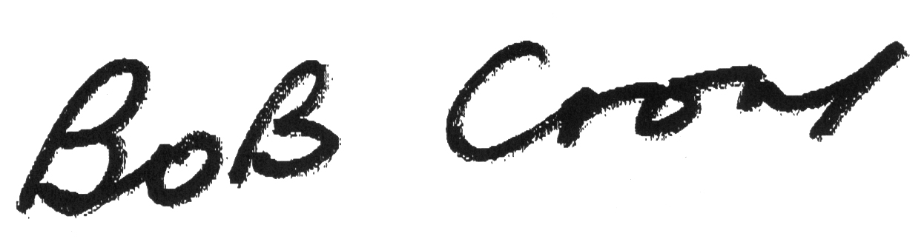
Bob Crow
General Secretary

